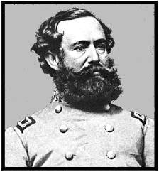 | The | JUly 2016
Legionary
A Publication of the Sons of Confederate Veterans
Lt. Gen. Wade Hampton Camp No. 273
Columbia, South Carolina www.wadehamptoncamp.org
Charles Bray, Acting Editor
A Fraternal Organization of Southern Men
Commanders Corner ^{Rusty Rentz}

As with May, our June meeting was very well attended. Traditionally during the summer months attendance is down. Let's make an effort to support the camp and that includes attending meetings.
Dues notices have been mailed and I encourage all members to remit their dues in a timely manner. All members are important even if you are unable to attend meetings and participate in events. There are some options to contribute additional funds to Division projects and to your local camp. I would ask each member to consider these as you pay your dues.
The camp inducted four new members at the June meeting. If we are to grow we need to continue adding to our ranks. Welcome to our newest members.
Our camp elects officers in November. The only two elected offices are Commander and Adjutant with the remainder of the executive committee and staff appointed by the Commander. We have many qualified members that can assume these positions.
Compatriots, we need a fund raiser (s). It is very difficult to fund ongoing projects from camp dues. At the June meeting I asked everyone in attendance to bring back in July a means of raising funds. If you are unable to attend this meeting you may phone me your suggestion at 803-359-7507.
On Saturday June 25, 2016 at 10:00 am an 8’x12’ Confederate Flag on a 70' pole was raised on Hwy 6 several miles outside Swansea. It was a sight to behold as the flag was blown by a gentle breeze. Gentlemen, I hope this is the first of many we can raise in the Midlands. This is another reason to raise additional funds. It is expensive to install these massive poles with large flags. Special thanks go out to one of our newest members, Rhett Ingram. He volunteered his property, materials, knowledge, finances and willingness to contribute this to the Confederate Cause just as his ancestor had done. A huge THANK YOU RHETT.
Out July meeting will be on Thursday July 21, 2016 at Seawell's Restaurant beginning at 6:00 pm with a meal. The program will be provided by Past Commander Colonel Bill Hollingsworth. His topic will be Wade Hampton and his Red Shirts. Make plans to be in attendance and as always invite a friend.
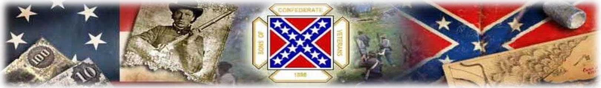
Lt. Commander’s Tent ^{Layne Waters}

~ Events of July ~
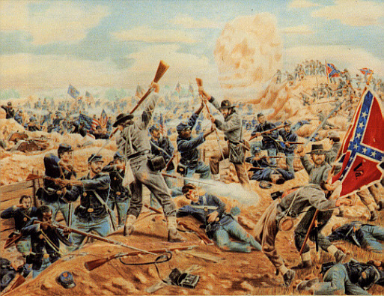
This Month (July), in 1864, as the two armies faced the stalemate of trench warfare at Petersburg, Gen. Ambrose Burnside agreed to a plan suggested by a regiment of Pennsylvania coal miners to dig a mine under the Confederate entrenchments and ignite explosives there to achieve a surprise breakthrough. The mine was detonated on July 30 in what is known as the Battle of the Crater. Because of interference from Meade, Burnside was ordered, only hours before the infantry attack, not to use his division of black troops, which had been specially trained for this mission. He was forced to use untrained white troops instead. He could not decide which divisions to choose as a replacement, so he had his three subordinate commanders draw lots. The division chosen by chance was that commanded by Brig. Gen. James H. Ledlie, who failed to brief the men on what was expected of them and was reported during the battle to be drunk well behind the lines, providing no leadership. Ledlie's men entered the huge crater instead of going around it, becoming trapped, and were subjected to murderous fire from Confederates around the rim, resulting in high casualties. Burnside was relieved of command on August 14 and sent on leave by Grant; Meade never recalled him to duty.
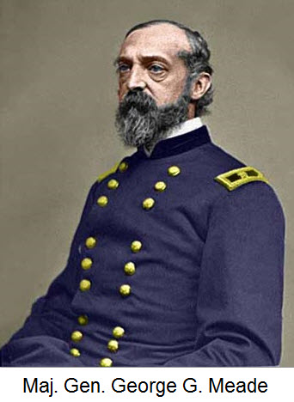 | 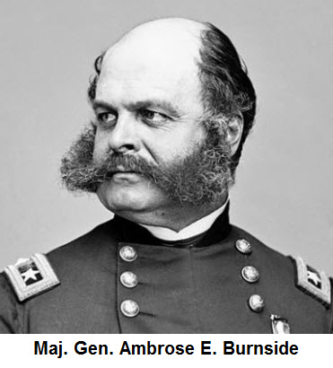 | 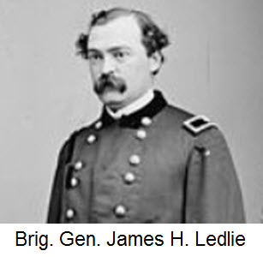
Chaplains Witness ^{Walter Lindler}

“THE VOICE OF THE LORD CAUSES THE OAKS TO WHIRL”
We have heard the voice of the lord coming to us in many different ways, through thunder storm and even through tornados. Sometimes other forms of GOD’s voices are heard as well.
Could GOD’s voice be heard through angels as well? What defines an angel? When a loved one dies, do they become an angel of GOD, serving him in heaven?
I recently had a discussion with someone that said, if we define a loved one who has died and is now in heaven, we cannot define them as an angel of GOD.
I disagree totally; I think that my mom is an angel of god serving him in heaven. My interpretation of an angel is someone who has gone before us to eternal life. If that is not the case, then where do the angels originate?
All my life I have been led to, believe that good people on earth go on to be angles in eternal life. I will always make reference to my loved ones who have died as angels of GOD. If this is not true then where does GOD gather his angels in heaven?
The voice of the Lord is through his angels from heaven. I have been told that an angel is of lesser image than a human being. I find that very hard to believe, and hard to understand.
GOD sees fit for us to join him in heaven when our work here on earth is finished. He takes us to our final resting place in eternal life. Our pains are healed and we become free of all maladies and cured of any dreadful diseases we may have encountered here on earth.
Father, GOD prepare us to come into your kingdom. While we serve you here on earth, prepare to heal all who are sick, depressed, confused and in need of your healing hand. We pray for our compatriots who are sick and those who have recently lost a love one.
“WHISPERING, WEEPING GOD, TURN OUR EAR TO YOUR VOICE, IN NATURE’S QUIET HUNTNG PLACES.” AMEN

Chaplains Prayer List: Please remember our camp compatriots and their family members who are having health problems or have lost a loved one in your prayers.
 | Jesse Folk  Michael P. Coleman | Ursula Slimp  Ann Smyth | Robert “Doc” Spigner | 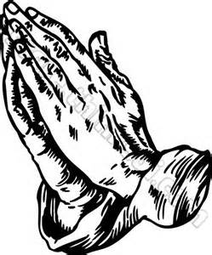

Adjutant’s Desk ^{Charlie Bray}

Compatriots, this is the fifth in a series of articles on the history of the “Confederate Soldiers” monuments erected in South Carolina. It is hard to believe that we began this series in March of this year, and are already in the fifth month of this journey. In this month’s issue, July 2016, of the Legionary we will present the history of the Oconee County Monument in Walhalla, SC, the Gist Rifles Monument in Westminster, SC, and the Aiken County Monument in Aiken, SC. As with the previous monuments presented in the Legionary, these 3 are also in jeopardy since they are located on public land, and the only thing protecting them is the Heritage Act.
Renewals have been mailed and I encourage you to renew your membership as soon as possible. I always become apprehensive during this time of year, but I have found when renewal season draws to a close, I’m overwhelmed with pride knowing that we are members of one of the strongest SCV camps in the Confederation. We have our work cut out for us defending our heritage in the years to come, but working together we can protect and preserve our heritage while carry on the “Charge”.
If you have questions or issues with your renewal package or have not received one, I may be reached as shown below:
Charlie Bray  507 Sail Point Way  Columbia, SC 29212-8711 | Home TN: 803-749-1042  Cell TN: 803-414-6808  E-Mail: cdbiii@bellsouth.net
REMEMBER: Mail your dues to me, at the address shown above, not to Joe Willis our Division Adjutant. If you mail your renewal to Joe then he has to mail it to me which slows down the process.
I have received an e-mail from SCV International Headquarters (SCV IHQ) stating they will no supply SCV logo window decals, but will sell them to camps for $10.00/dozen decals. I regret we will no longer be sending the decals out with the renewal letter and ID card.

Oconee County Monument – Walhalla, SC
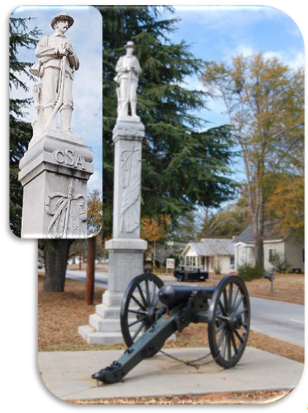  West Side  “CONFEDERATE SERVICE  SIX HUNDRED THOUSAND MEN  FEDERAL SERVICE  TWO MILLION, SIX HUNDRED THOUSAND MEN” | North Side  “ON FAME'S ETERNAL CAMPING GROUND  THEIR SILENT TENTS ARE SPREAD  WHILE GLORY GUARDS THE SOLEMN ROUND  THE BIVOUAC OF THE DEAD”  South Side  “THE LAND THEY STRUGGLED TO SAVE FOR US  WILL NOT FORGET  ITS WARRIORS YET  WHO SLEEP IN SO MANY A GRAVE FOR US.”  .East Side  C.S.A.  (half-furled flag covering the full length of the shaft)  THIS MONUMENT IS DEDICATED TO THE MEMORY OF  THE CONFEDERATE SOLDIERS  BY THE WOMEN OF OCONEE COUNTY. THESE GALLANT SOLDIERS GAVE THEIR LIVES  FOR THE PRINCIPLE OF STATES RIGHTS,  FOR THE PROTECTION OF THEIR HOMES, AND IN DEFENCE OF THEIR WOMEN AND  CHILDREN. WE, WHO KNEW THEM,  TESTIFY THAT THEIR COURAGE WAS  WITHOUT A PRECEDENT, THEIR FORTITUDE WITHOUT A PARALLEL, THEIR VIRTUES  OF THE HIGHEST, AND THAT THEY KNEW  NO LAW OF LIFE BUT LOYALTY, TRUTH  AND CIVIC VIRTUE, AND TO THESE  PRINCIPLES THEY CONSECRATED  THEIR LIVES AND FORTUNES.  1861 - 1865  OUR CONFEDERATE DEAD
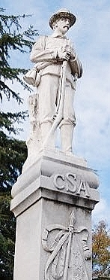
Rebecca Hunter developed the original idea of building a monument to Oconee County’s Confederate soldiers and generated interest among several friends. Most were the wives and daughters of former Confederate soldiers. In May 1892, this group met at the Walhalla County Courthouse and created the Ladies’ Monument Association of Oconee County. Rebecca Hunter, the organization’s primary mover and most faithful worker, was elected president. The women spent the next eighteen years raising money for the monument.
The project drew opposition. Some townspeople thought it was an unnecessary expense; others thought it too costly. A dispute also arose over where the monument should be erected. Nevertheless, the women persisted, selling ice cream, serving dinners at the courthouse during Court Week, giving other entertainments, and soliciting contributions and subscriptions. The death of Rebecca Hunter cast gloom over the association’s fund raising efforts. Money was still needed, and activity lagged. Julia Johnson and Mrs. S. K. Dendy took over. They canvassed the county, organized the Joseph Norton Chapter, U.D. C., and succeeded in raising the money. Stiles P. Dendy, captain of Company C, 2nd S.C. Rifle Regiment, is said to have contributed the first and last dollar the fund.
The chapter was named in honor of Joseph Jeptha Norton, who was captain of the Pickens Boys, Company C, Orr’s Rifle Regiment (First S.C. Rifles). He was promoted Major in August 1862, lieutenant colonel in December 1862, lost an arm at Fredericksburg, and spent the remainder of the war as the enrolling officer in Pickens District.
The final cost of the monument was $1,072.24. The dedication ceremony took place 105 years ago on July 21, 1911, on the fiftieth anniversary of the first battle of the war. A crowd of about 3,500 attended. The 200 veterans there were treated to an automobile ride as the honored guests. A parade followed, starting at the monument going four blocks down the north side of Main Street, ten returning on the south side of the street. The parade comprised the mounted marshals of the day, the maids of honor, the chaplain and unveiling maids, the speakers, a company of one hundred girls followed by a company of one hundred boys, and finally, a small cannon named the “Pendleton Peace Maker.” Dr. John Gordon Law, a veteran of the 38 Georgia Regiment, gave the opening prayer. Governor Martin F. Ansel, an Oconee native, made a brief address. Then, two young girls, both granddaughters of veterans, drew the cords and unveiled the shaft to “a mighty roar of cheers and applause.” The band played “Dixie,” the cannon fired three salutes, and the crowd retired to the school building. Three, Robert A. Thompson, sole survivor of the signers of South Carolina’s Ordinance of Secession and former lieutenant colonel of the 2nd S.C. Rifle Regiment (Moore’s Rifles), introduced the first speaker, Robert Thompson Jaynes, and “applauded to the echo. Jaynes, an Oconee County native who practiced law in Walhalla, delivered a well-received address. Anderson lawyer, Milledge L. Bonham, son of the Confederate general delivered the closing address, “a masterpiece,” which the crowd received with frequent and prolonged cheers. The twenty-four-foot monument was originally placed in the median of Main Street of its present location.

Confederate Soldiers Monument – Westminster, S.C.
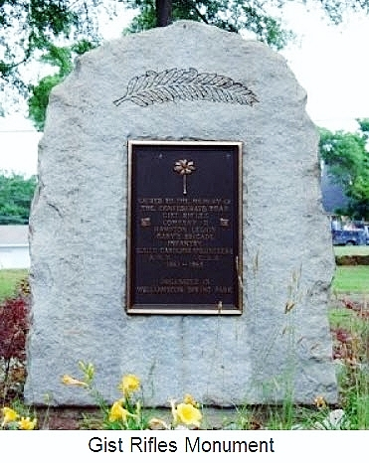
(palmetto tree)

SACRED TO THE MEMORY OF
THE CONFEDERATE DEAD
GIST RIFLES
COMPANY D
HAMPTON LEGION
GARY’S BRIGADE
INFANTRY
SOUTH CAROLINA – VOLUNTEERS
A.N.V. - C.S.A.
1861 – 1865
ORGANIZED IN
WILLIAMSTON SPRING PARK

The Gist Rifles, also called the Gist Riflemen and Gist Guards, was a company composed of men primarily from Anderson and Pickens Districts with some from Greenville and Spartanburg Districts. In April 1861, President Jefferson Davis authorized raising a “Legion of Honor” to be under his direct orders. The legion was to comprise six infantry companies, four cavalry companies, and one artillery company. The legion would enlist for one year of service in the Confederate States Provisional Army, and the president would appoint all field officers. Wade Hampton was elected to be the colonel of the legion, and it took his name. The Gist Rifles probably mustered in Columbia on June 12, 1861, along with the other five infantry companies of the elite Hampton Legion.
The infantry, Calvary, and artillery components of the Hampton Legion were broken up after the first battle of Manassas. The Gist Rifles remained with the Infantry Battalion of the Hampton Legion, which was augmented to become a full infantry regiment by December 1862. After the Knoxville Campaign in 1863, the regiment was mounted and reassigned to M. W. Gary’s Cavalry Brigade, with whom it finished the war. The S.C. Division of the U.D.C., unveiled the granite marker in 1941 for $200.00. It stands 5-and-a-half feet. The marker is located on the grounds of Mineral Spring Park near East Main Street.
Aiken County Monument – Aiken, SC
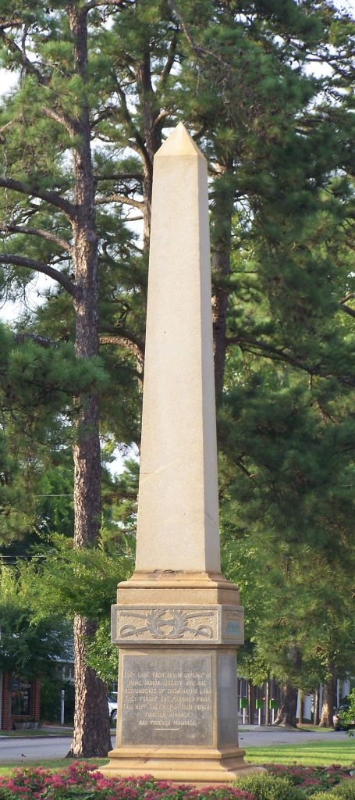 | North Side  ERECTED JULY 23, 1901  BY THE  LADIES MONUMENT ASSOCIATION  OF AIKEN S.C.  IN LOVING TRIBUTE TO THE  CONFEDERATE  SOLDIERS  OF AIKEN COUNTY
South side
THEY GAVE THEIR ALL IN DEFENSE OF
HOME, HONOR, LIBERTY AND THE
INDEPENDENCE OF THEIR NATIVE LAND
THEY FOUGHT THE PATRIOTS FIGHT
THEY KEPT THE FAITH OF THEIR FATHERS
FOREVER HONORED
AND FOREVER MOURNED
 | The Ladies’ Monument Association of Aiken organized on May 20, 1892. It raised the necessary $700.00 and unveiled this twenty foot monument of polished Carolina granite 115 years ago on July 23, 1901, near the railroad station in full view of the traveling public. The monument remains in the original location, which is in the center of one of Aiken’s beautiful parks at the intersection of Chesterfield street and Park Street. The monument is in a traffic island in the middle of this intersection just north of the Aiken County Courthouse. On dedication day, the crowd came from as far away as Augusta, Georgia, and filled the park. Two daughters of Benjamin H. Teague, formerly a private in the Watson Guards, Company B, the Hampton Legion, introduced the orator of the day, the
Honorable J. Rice Smith, Congressman W. J. Talbert also addressed the assemblage. Former Brigadier General Ellison Capers penned the inscription for the monument, as he had for several other Confederate monuments in the state.
The granite obelisk was erected in 1901 by the Ladies Monument Association of Aiken S.C. The monument stands approximately 18 ft and is 3 feet 1 inch wide. The base is 2 feet high by 7 feet 5 inches wide.
Calendar Of Upcoming Events ²⁰¹⁶ ⁻ ²⁰¹⁷

Event | Date | Contact / Web Site
Palmetto Camp 22 | Aug. 4, 2016 | Meets 6:30 PM 1st Thursday of the Month – Cayce Museum, 1800 12th Street, Cayce, SC
John M. Kinard Camp 35 | Aug. 3, 2016 | Meets 7:00 PM 1st Wednesday of the Month – Hawg Heaven – Hwy. 76, Prosperity, SC
15th Regt. S.C. Volunteers Camp 51 | July 26, 2016 | Meets 6:30 PM last Tuesday of the Month – Lizards Thicket – 4616 Augusta Rd. Lexington, SC
Gen. Paul Quattlebaum Camp 412 | July 28, 2016 | Meets 7:00 PM Last Tuesday of the Month– Shealy’s BBQ – 340 East Columbia Ave., Batesburg-Leesville, SC
Confederate Ghost Walk | Oct. 14 & 15, 2016 | Magnolia Cemetery 70 Cunnington Ave. Charleston, SC  http://csatrust.org
Lexington Veterans Day Parade | Nov. 6, 2016 | Details to be provided
Columbia Veterans Day Parade | Nov. 11, 2016 | Details to be provided
Christmas in Cayce | Dec. 3, 2016 | Details to be provided
West Metro Parade of Lights Christmas parade | Dec. 10, 2016 | Details to be provided
Battle for Pocotaligo | Jan. TBA | Directions are provided on web site - www.pocotaligo.com
Hunley / Housatonic Memorial Service | Feb. 17, 2017 | 7:00PM at Sunrise Presbyterian Church 3222 Middle St. Sullivan’s Island, SC - http://csatrust.org
The Battle for Broxton Bridge | March – TBA | 152nd Anniversary of the Battle  1685 Broxton Bridge Rd.  Ehrhardt, S.C.  http://broxtonbridge.com/
RECRUIT A NEW MEMBER.
Contact Scott James / (803) 781-1836 / E-Mail: wscottjames@bellsouth.net

Important Dates in Lincoln’s War to Prevent Southern Independence
July 13, 1861 | Battle of Corrick's Ford - While directing his rear guard Gen. Robert Garnett [CS] is shot and dies minutes later. He is the first general on either side to die in the line of duty during the WBTS. | Camp Meeting  Thursday, July 23  6 o’clock p.m.  Seawell’s Restaurant  1125 Rosewood Drive  Columbia, SC  Speaker  Bill Hollingsworth – “Wade Hampton and his Red Shirts”
July 22, 1861 | In a proclamation Jefferson Davis accepts Tennessee as a member of the Confederacy.
July 25, 1861 | The Crittenden Resolution passes in Congress. This states the Preservation of the Union is the reason for the Civil War
July 9, 1862 | Confederate Col. John Hunt Morgan launched his famous "First Kentucky Raid" and his first objective was the destruction of the Union forces in Tompkinsville, KY. The raiders positioned two cannons and fired into the Union camp, then carried it by a dashing charge. Within two hours the battle was over. The Confederates had captured the garrison and many Union soldiers, including its commander Major Jordan.
July 3, 1863 | John Pemberton, commander of Confederate forces at Vicksburg asks Ulysses S. Grant for terms. Grant demands an unconditional surrender. Pemberton refuses. Late in the evening, Grant offers excellent terms and Pemberton accepts.
July 18, 1863 | The 54th Massachusetts, comprised primarily of free blacks from Massachusetts and Pennsylvania, attack Battery Wagner in Charleston Harbor, losing 30% of their men and forcing Gen. Quincey Gillmore [US] to lay siege to the city.
July, 1864 | Confederate President Jefferson Davis told a Northern journalist in July 1864, "we are fighting for INDEPENDENCE and that, or extermination, we will have. "You may 'emancipate' every negro in the Confederacy, but we will be free. We will govern ourselves . . . if we have to see every Southern plantation sacked, and every Southern city in flames."

